1. Install NodeJS

<https://nodejs.org/en>

1. Check your Node version

Node --version

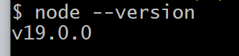

1. In node there is GLOBAL object
2. Standard way of a node module is asynchronous
3. It can also be made synchronous